Contents

How to open Cashier App 2

Navigation in application 3

Menu: Operation Tab 4

Menu: History Tab 5

Menu: Warehouse Tab 6

Workflow 7

# How to open Cashier App

1. Double click on “Cashier.exe”  
   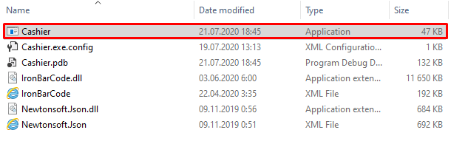
2. On first start you will get a couple of notification windows, you might skip them by clicking “Ok”  
   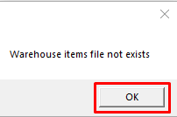

# Navigation in application

This is main window of application. You will see it every time you do start the application

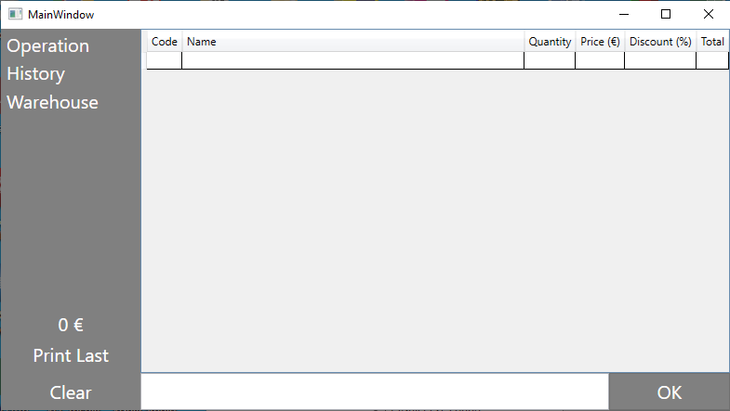

On left side, there is a navigation menu, you might change your active window by simply clicking on to text. Operation Tab is selected by default on application open.  
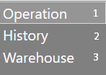

## Operation Tab

## History Tab

## Warehouse Tab

# Menu: Operation Tab

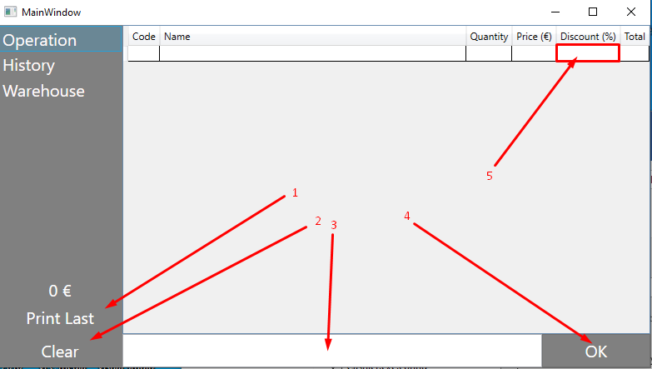

On Operation Tab these controls are available:

## “Print Last” – will print out last receipt

## “Clear” – will wipe current table

## This is “Item Code” or “Item ID” text box. Once you’ll **insert** inside of this textbox **numeric code** of Item and click **“Enter” button**, new Row will appear in this table. (Adapted for barcode scanner)

## “OK” – will finish current operation

## “Discount (%)” – editable column for applying discount to selected row.

# Menu: History Tab

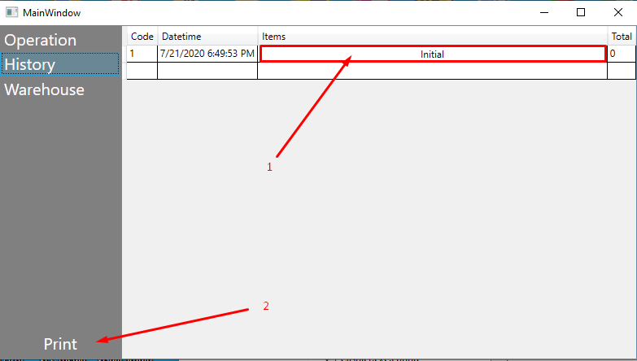

## “Items” column – click on this column will display you “Operation Table” for this operation.

## “Print” – will print a receipt for selected operation.

# Menu: Warehouse Tab

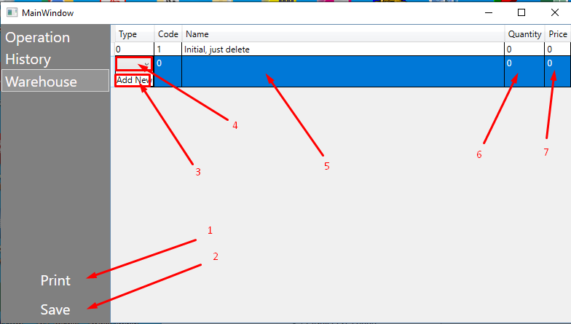

## “Print” – will print one barcode label for selected Warehouse Item.

## “Save” – will save changes.

## “Add New” column button – will open window, what will let you to add/modify “Type” values

## “Type” column combobox – will show you a list of available Types for grouping Warehouse Item

## “Name” column textbox – will let you to store name of your item.

## “Quantity” column textbox – will let you to manage amount of items in your stock.

## “Price” column textbox – price for following warehouse item.

# Workflow

## To start working with an application, first you need to insert your items on “Warehouse”

## Go to Warehouse Tab (3)

## Click “Add new” in “Type” column (3)

## Insert your item Types (Groups of goods)

## Click “Save” and close the window

## Select “Type” from combobox (4) (If newly created items are not appeared in combobox, try to switch selected row on another and back)

## Insert Item Name into “Name” column (5)

## Insert Quantity (6)

## Insert Price for one Item (7)

## Click “Save” button (2)

## Repeat as many times as you need.

## Now you’re ready to work with application. Switch back to Operation tab. (1)

## Click on textbox window (3)

* 1. Insert Item Code (From Warehouse Item) or scan a barcode label
  2. Click “Enter” (if you have scanned a barcode, then it’s not needed)
  3. Total sum of invoice will be displayed here (1)  
     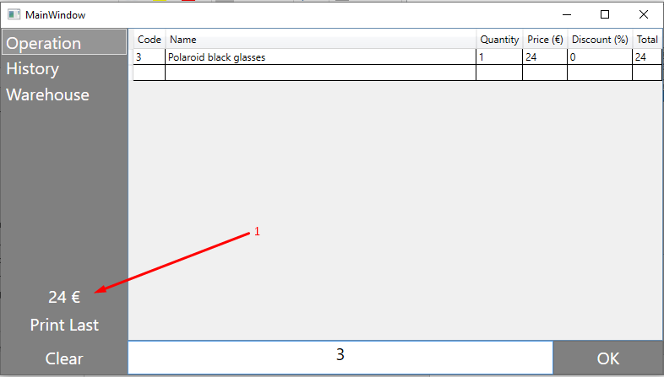
  4. Once all items are added to list, click “OK” button (4)  
     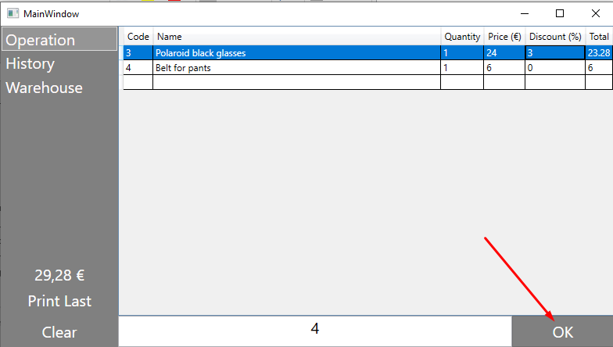
  5. Receipt will be printed out.
  6. This operation will be saved in History Tab (2)  
     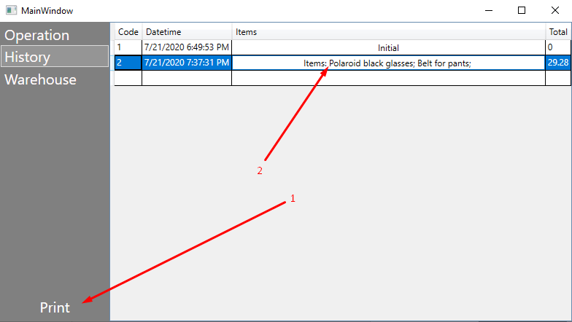  
     Click on “Print” button (2) will print receipt for this operation  
     Click on “Items” column (1) will display you table with this operation  
     